**Tableau insights COURSEWORK**

Dataset analysis and recommendations



**Word count: 1497 (excluding executive summary, table of contents, figures, headings and subheadings, footnotes)**

Name: Clare Kuan Sze Sing

Student number: 220456793

**EXECUTIVE SUMMARY**

This whole report wishes to offer a comprehensive examination of the multi-year dataset, providing a clearer look into both customer behaviour and market trends. The examination will delves across various measurement metrics, from regional to sub categorical groups, with the specific end goal of offering the company detailed insights into their numbers. Beyond numerical analysis, recommendations are also given unsparingly to boost consumption and company revenue.

The main report tackles five main dashboards, each designed to highlight its individual set of insights and visualisations:

1. Region and Order priority affecting profits
2. States’ shipping costs
3. Forecasted profits of categories
4. Factors affecting profits in sub-categories in a country
5. Customer’s loyalty

Overviews of key insights for each respective dashboard are as follows:

1. Central with medium priority yields highest revenue but has declined over the years due to excess discounts
2. California witnesses significant fluctuations in overall and monthly shipping costs
3. Technology is the most profitable category
4. Shipping costs is the main variable that affects sub categories’ profit
5. Over time, there’s a higher loyal customer base

Following the insights, the subsequent section of the report talks about recommendations tailored to the insights with some overlapping key suggestions. In summary, they are customer segmentations, optimising shipping costs, market basket analysis and implementing a customer loyalty card.

Contents

1. Introduction 3

2. Insights from Story 4

2.1: Dashboard 1: Analysing Region and Order Priority effect on Profits 4

2.2: Dashboard 2: States and their Shipping Cost 9

2.3: Dashboard 3: Categories Forecasted Profits 13

2.4: Dashboard 4: Country’s Sub categories’ factors relating to profit 16

2.5: Dashboard 5: Customer’s loyalty 18

3. Recommendations based on Insights 21

3.1: Recommendations based on dashboard 1 21

3.2: Recommendations based on dashboard 2 21

3.3: Recommendations based on dashboard 3 22

3.4: Recommendations based on dashboard 4 23

3.5: Recommendations based on dashboard 5 23

4. APPENDIX 25

# 1. Introduction

We were task to present an overview of the dataset the company has gathered over number of years. To make sense of such vast data, we have adopted a multi-layered approach, consisting of meticulously filtering, mining and breaking down the enormous data into bite sizes diagrams in an effort to curate a more comprehensive reading and look into the company’s performance across the years. We pride ourselves in presenting clear visualisations of data through detailed observations and suggesting pertinent recommendations for the company’s future endeavours. We anticipate that this complete analysis is a useful foundation for future decision-making and strategic marketing ideas for the company.

In the subsequent sections, we will slowly unravel the different layers of the data, providing a better understanding of their individual representation to the stakeholders, enhancing the company’s revenue.

# 2. Insights from Story

## 2.1: Dashboard 1: Analysing Region and Order Priority effect on Profits

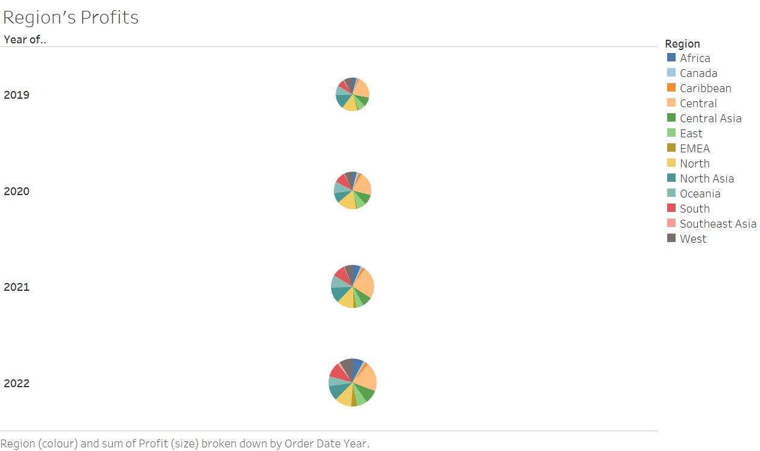

Figure 1: Different region’s gross profits

2.1.1: Region’s observations

Analysing Region’s profits, we can observe that the Central[1] has consistently dominated the chart across the years. This pattern has prompted us to examine the underlying reasoning behind such sustained profitability.

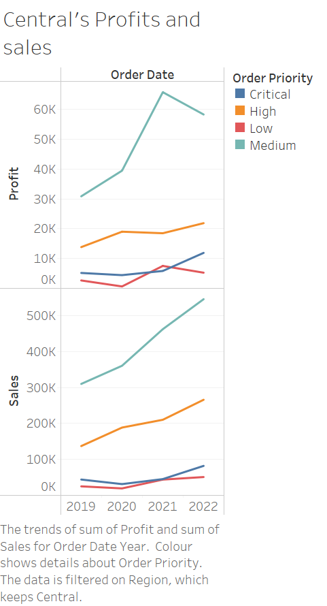

Figure 2: Central profit and sales

2.1.2: Central’s observation

The profit and sales diagram of Central region reveals two main trends:

* Medium priority products consistently yield the highest sales
* Profit and sales having a direct correlation with each other

However, at a glance it is also clear that between 2021 and 2022, medium priority profits decline despite increased sales. Consequently, we did a focused filtering of the medium priority dataset below to establish relationships.

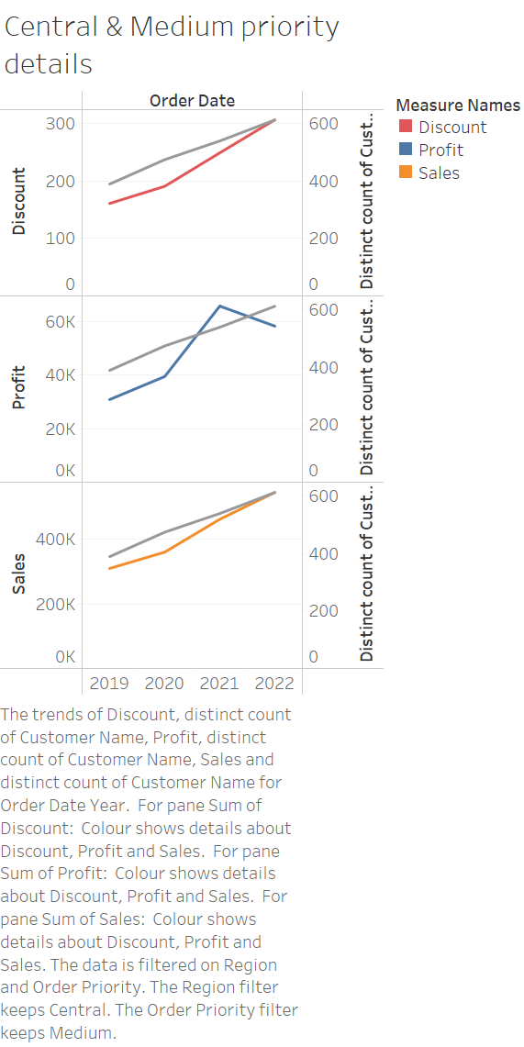

Figure 3: Central & medium order priority details

2.1.3: Central & medium order priority’s observation

Upon further analysis, the above diagram reveals that an uptick in discounts stands out as the main factor leading to decreased profits. This is a consequence from high numbers of distinct customers as represented by the grey lines in the subgroups.

## 2.2: Dashboard 2: States and their Shipping Cost

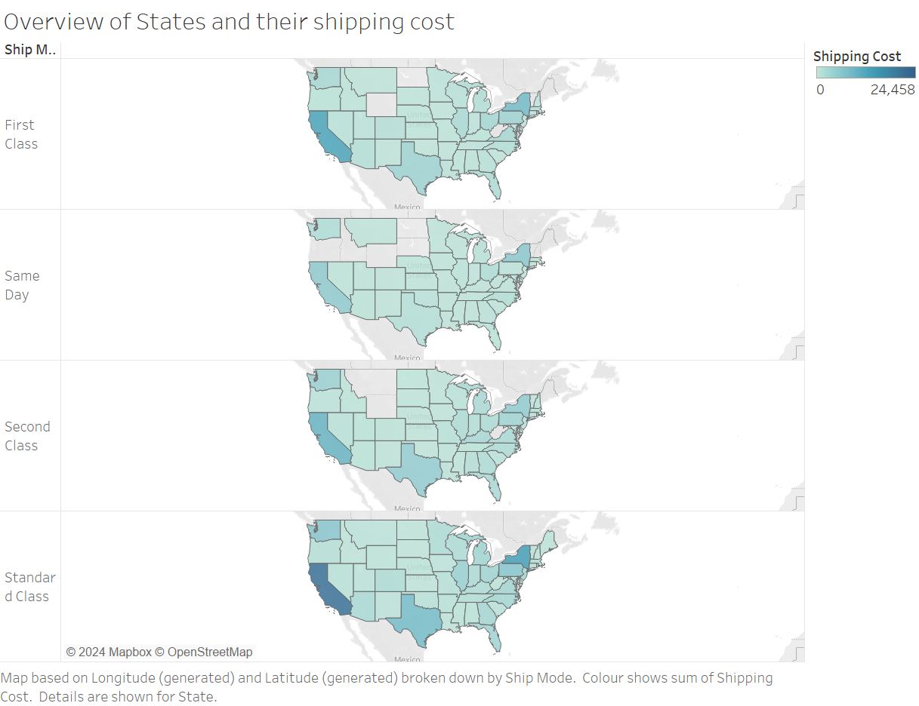

California

Figure 4: Overview of individual states and shipping costs

2.2.1: Overview observations

Figure 4 highlights California as the state with the most variations in shipping costs across different shipping modes. Hence, in the following sections we will be delving further into its dataset

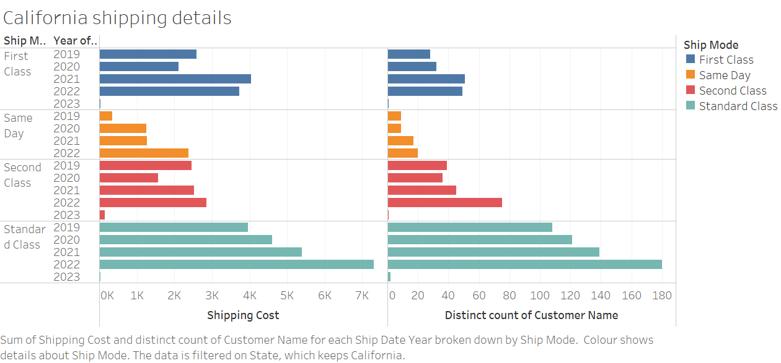

Figure 5: California’s shipping data

2.2.2: California’s observations

Figure 5 displays shipping costs distribution across various modes over 5 consecutive years. A display of corresponding distribution of distinct customer names is present to streamline focus. Our investigations will center on the standard class due to its highest distinct count, providing an accurate representation of the majority and their impact on overall shipping costs. In addition, we can observe that a higher distinct count of customer generally relates to a higher shipping cost as well among the different shipping modes.

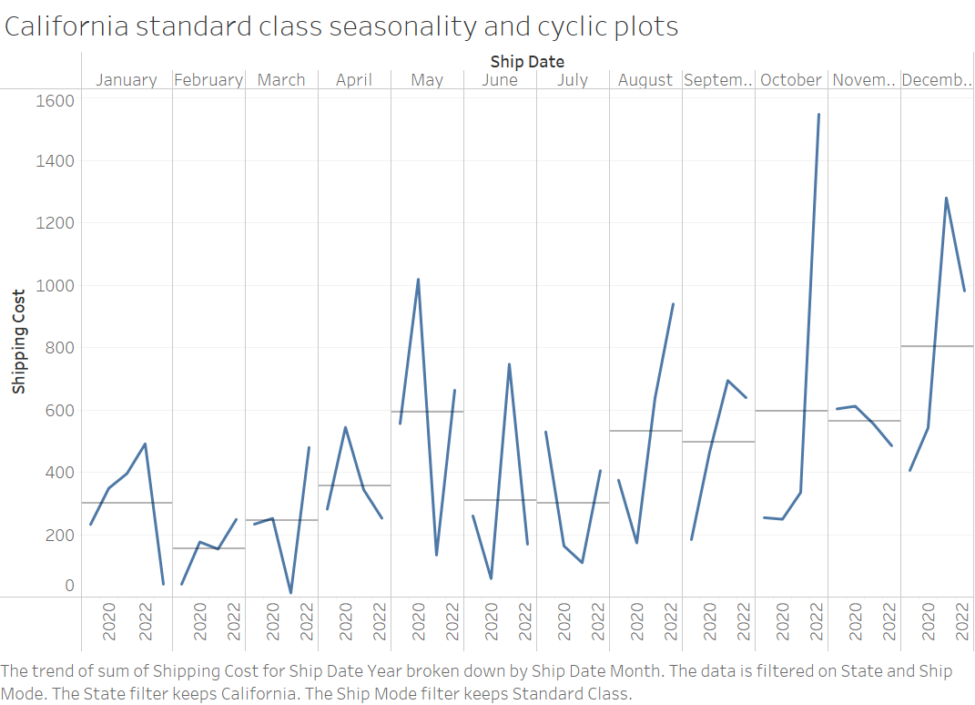

Figure 6: Seasonality of standard class shipping mode in California

2.2.3: Seasonality observations

Figure 6 indicates that February sees the lowest shipping costs possibly due to sales while October and December generally incur the highest. In addition, October shows a steady upward trend, suggesting a sustained growth in shipping costs and quantity. Notably, May and June exhibits significant heavy fluctuations in shipping costs.

## 2.3: Dashboard 3: Categories Forecasted Profits

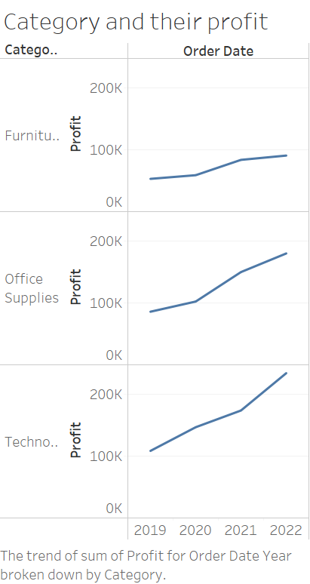

Figure 7: Different categories and their respective gross profits

2.3.1: Categories’ profit observations

The depicted figure shows the general upward trend of profit across categories over the years. Technology appears to exhibit highest profit growth with Furniture trailing behind the other two categories. Subsequent figures will examine the specific details to paint a better picture on the factors and their forecasted growth.

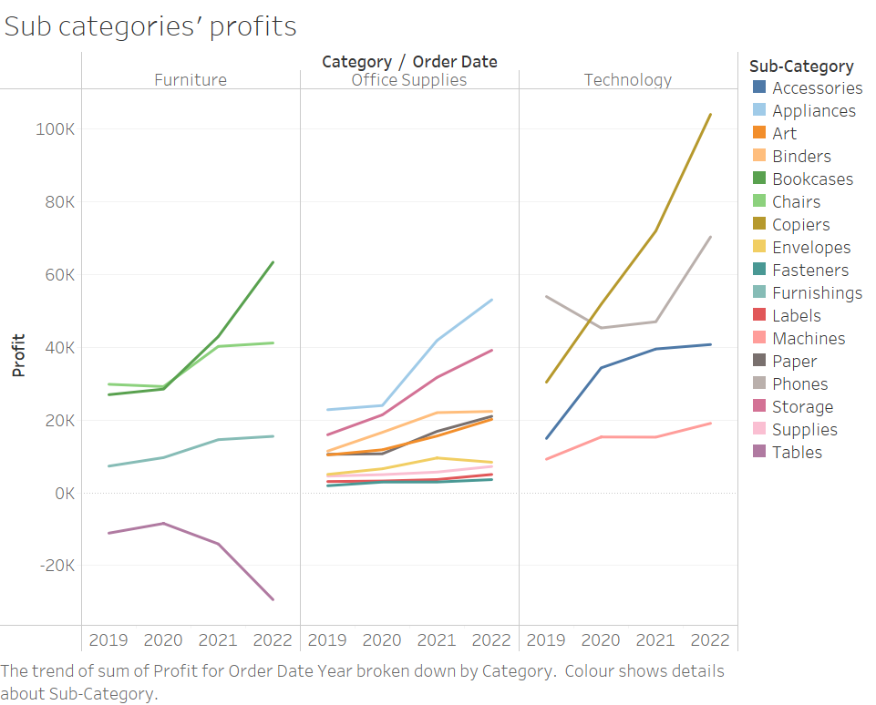

Figure 8: Sub categories’ profit details

2.3.2: Sub categories observations

Figure 8 indicates a positive relationship between profit and year across most sub categories. To gauge the potential growth of each category we have selected the best and worst selling item to establish a median profit benchmark.

Despite an anomaly where tables incur losses over time, this item will still be included in the forecast below to provide an overall representation of the profitability of its category.

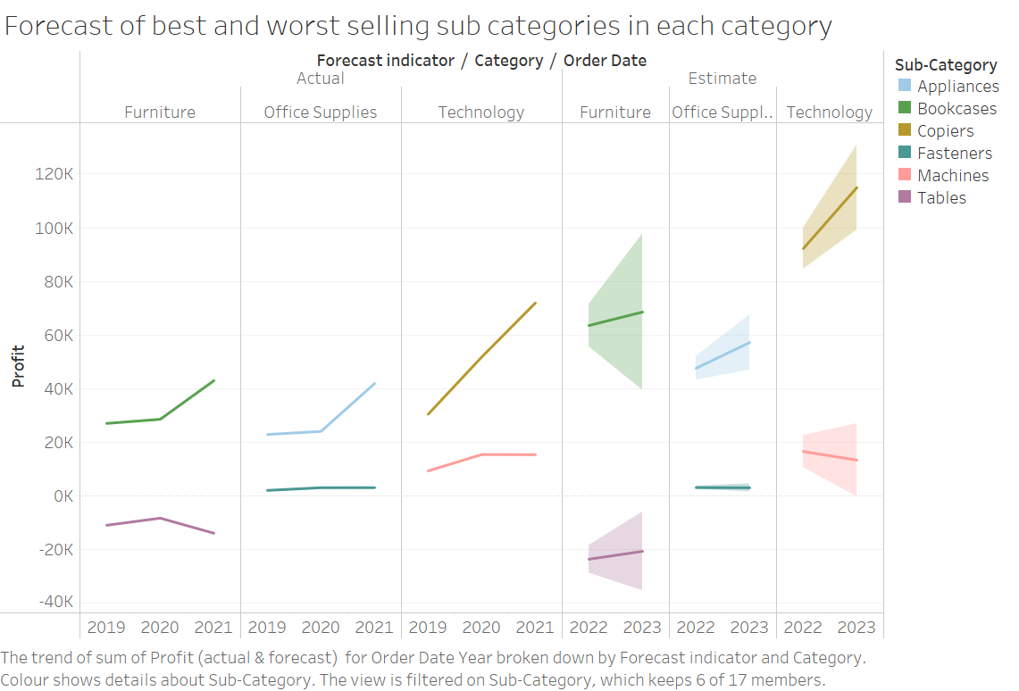

Figure 9: Profit forecast

2.3.3: Forecast’s observations

From figure 9, the most profitable category is Technology, evident from the forecasted results illustrating a high gross profit even from its worst selling item. In contrast, Furniture would be the least profitable, with its worst selling item; tables still incurring losses.

Despite Bookcases, grossing nearly 10k more than Appliances, projected revenue of Furniture still falls short of Office Supply.

## 2.4: Dashboard 4: Country’s Sub categories’ factors relating to profit

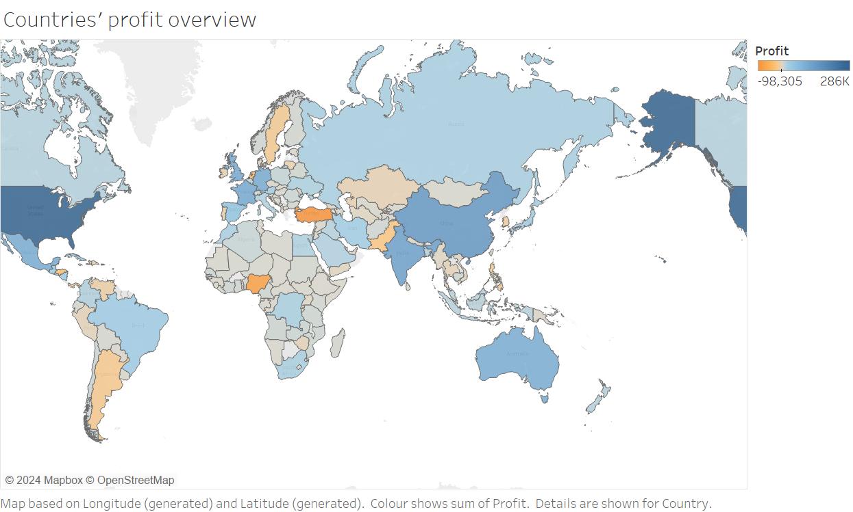

Turkey

Figure 10: Overview of countries and their profits

2.4.1: Countries observation

The most important observation from the geographical diagram is that Turkey has experienced the highest losses among all countries. Following sections will examine the factors and provide some insight to shed light on the circumstances that led to this situation.

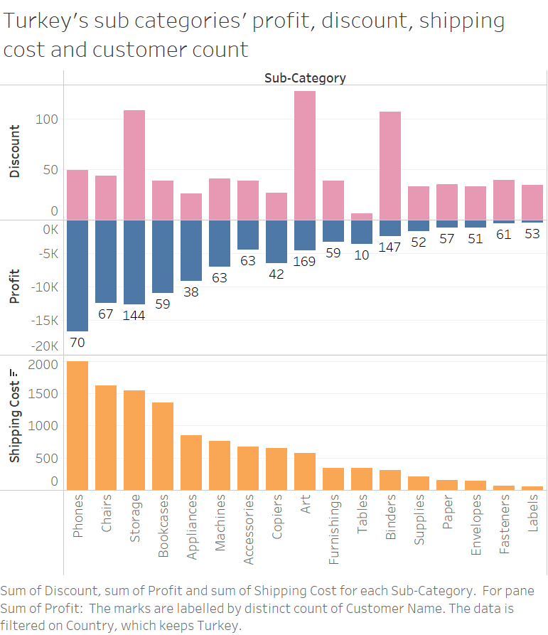

Figure 11: Factors affecting Turkey’s profits

2.4.2: Turkey’s observation

Key observations include:

* A decrease in shipping costs relates to decrease in incurred loses
* Higher discounts causes a rise in customer count
* However there seems to be little to no correlation between either discounts and customer count with profits
* There also appears to be very little pattern between either discounts and customer count with shipping costs

We can concluded that while number of customers and discounts could be the contributing factors of the losses, the primary problem affecting profit is in fact the closely intertwined relationship with shipping costs.

## 2.5: Dashboard 5: Customer’s loyalty

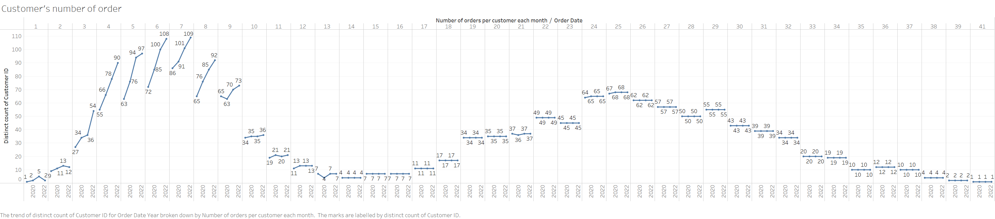

Figure 12: Distinct customer orders per year

2.5.1: Overview of customers’ order observation

The figure clearly indicates that most of the customers would engage around 6-7 transactions. Their most preferred transactions also ranges 4-9. After that the transactions experiences a steep decline with only a small peak at around 24-25 transactions.

In an effort to get an astute understanding of customer behaviour the figure below will serve to see quarterly returning rate of customers regardless of their number of transactions to see how willing they are to purchase again.

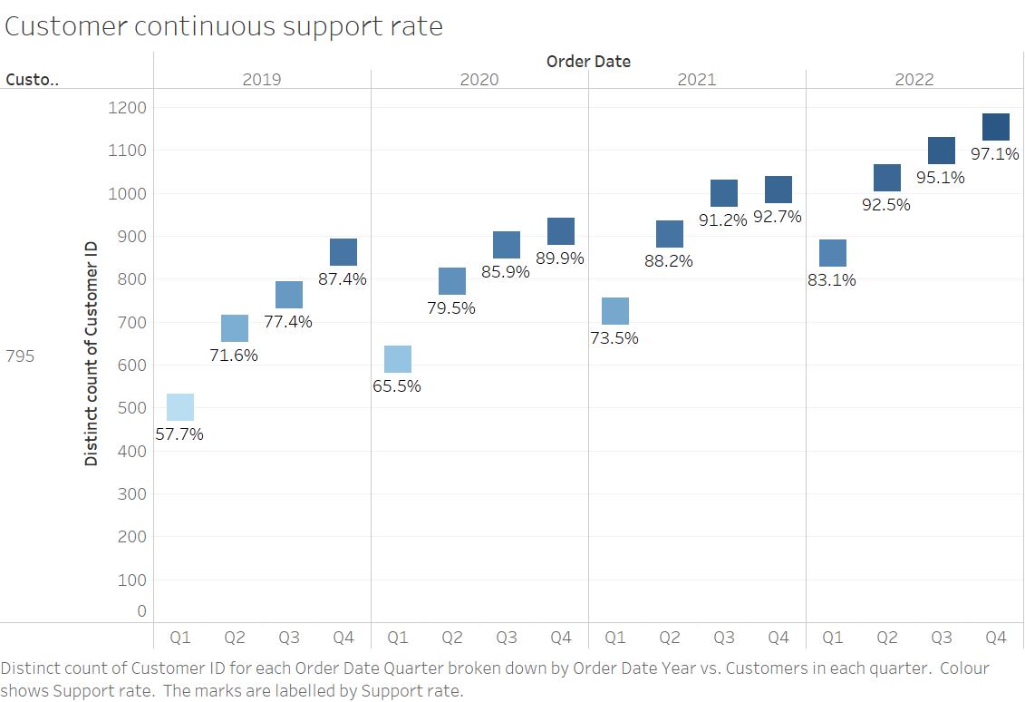

Figure 13: Returning rate of customer

2.5.2: Returning rate observations

The key observations are as followed:

* Quarter 1 to Quarter 4 support rate increases over the years
* Quarter 1 always has the least amount of support rate
* Across the years the support rate in all Quarters has increased

We can conclude that over the years, customers are more inclined to continue their purchase with the company and that there is an increase in brand loyalty.

# 3. Recommendations based on Insights

## 3.1: Recommendations based on dashboard 1

The primary recommendation is customer segmentation based on financial capacity. This approach involves grouping all customers by their income to tailor discounts[2]. This method eliminates any unnecessary added discounts to customer segments that have the ability to tank the more expensive costs, allowing higher profit margin from this segment in the forthcoming year.

A targeted approach like this actually ensures strategic placement of discounts by making it affordable to customers with lower disposable income. Simultaneously, it is more lucrative for the company as it cannabises on the wealthy, forcing them to pay the full costs.

## 3.2: Recommendations based on dashboard 2

To provide suitable recommendations, we have decided to break it down into its respective figures due to their complexity.

The key recommendations are as followed:

* For state wise like California, we recommend sourcing better alternatives to ship the products in relation to their shipping mode
* For the standard shipping mode, we recommend optimising shipping quantity per trip
* In terms of seasonality, we recommend using both aforementioned strategies with added considerations for each month. This includes factors such as seasonal changes and weather conditions

Both alternative sourcing and optimising shipping quantity aims to provide more cost effective ways to ship products to customers. Through alternative sourcing, the company can find cheaper carriers while maintaining their original quality. For optimising shipping quantity, the company can look into methods like bulk shipping to a warehouse first for storage. Both approaches directly also increases competition in the shipping industry, encouraging these companies to offer cheaper avenues to keep cooperation with companies in fear of brand switching.[3]

These two strategies should be flexible and used simultaneously to tackle seasonal variations, as each unique month requires a different method of approach to rake in revenue.

## 3.3: Recommendations based on dashboard 3

The recommendation mainly will be to conduct a market basket analysis. This way, we can gain valuable insights into customer’s purchasing patterns and identify overlap of products purchased.[4] By having a clearer idea of the relationships between the products, the company can capitalise the information to provide personalised recommendations of the bundled goods. This approach advertises low selling products like Tables to have more visibility to customers who have purchased related products like Bookcases within the Furniture category. We strive to enhance overall profitability of the different categories whilst improving the customers’ shopping experience through thorough analysis of patterns in product purchases.

## 3.4: Recommendations based on dashboard 4

Our primary recommendation specifically will be optimising shipping costs. Similar to the recommendation mentioned in Section 3.2; we will continue to advise sourcing or outsourcing cost-effective shipping methods for both international and domestic goods. In addition as a follow up recommendation, we also suggest adjusting discounts like Section 3.1. By setting up clearer profitability goals and fully taking advantage of the high customer count, it cushions drops of sales in months of higher shipping costs, enabling an overall sustained profit over time.

## 3.5: Recommendations based on dashboard 5

We recommend a strong emphasis on nurturing customer loyalty, proposing the introduction of customer loyalty cards equipped with QR or bar codes. Scanning these cards after purchases allows for generally easier data collection. This data then serves as a dynamic learning tool to make correlations in customers’ purchasing patterns, enabling easier identification and rewards to loyal clientele.

The company should actively employ bonuses to enhance customer-shopping experiences after accurately recognising its loyal customers. Bonuses include loyalty discounts like exclusive cash-back schemes throughout seasonal shopping, and complementary gifts accumulated through purchase points. Moreover, to encourage spending, these loyalty benefits are tiered, with rebates directly corresponding to expenditure on the company’s products.[5] This method serves more than a retention strategy, it is an incentive for new customers and fosters lasting relationships with the company. The envisioned outcome is both sustained loyalty with organic expansion of clientele and substantial growth in revenue.

# 4. Appendix

(Christiana Jolaoso, 2023) Customer segmentation: The ultimate guide. Available at: <https://www.forbes.com/advisor/business/customer-segmentation/>

(Ana Swanson, 2022) With Inflation Surging, Biden Targets Ocean Shipping. Available at: <https://www.nytimes.com/2022/03/21/business/economy/inflation-biden-shipping.html>

( ANNA KAYFITZ, 2019) Use Market Basket Analysis to Boost Cross-sales, Average Order Values. Available at: <https://www.practicalecommerce.com/use-market-basket-analysis-to-boost-cross-sales-average-order-values>

(Jordyn Holman and Julie Creswell, 2023) Shoppers, Facing Holiday Spending, Turn to Loyalty Programs. Available at: <https://www.nytimes.com/2023/12/09/business/holiday-shopping-loyalty-programs.html>

**Image used:**

<https://static.vecteezy.com/system/resources/thumbnails/000/158/932/small/bookkeeping-vector-illustration.png>

1. Pastel orange area
2. https://www.forbes.com/advisor/business/customer-segmentation/
3. https://www.nytimes.com/2022/03/21/business/economy/inflation-biden-shipping.html
4. https://www.practicalecommerce.com/use-market-basket-analysis-to-boost-cross-sales-average-order-values
5. https://www.nytimes.com/2023/12/09/business/holiday-shopping-loyalty-programs.html